**DBMS Project Report**

Restaurant management system

Introduction:

Online Restaurant Management system is a process of ordering food from a restaurant or food co-operative through a web page or app.Much like ordering consumer goods to keep accounts with them in order to make frequent ordering convenient.A customer will search for a favourite restaurant and choose from available items,and gives feedback.

Objective:

* A Data based management system is designed to handle all the primary information required to calculate monthly statement
* This project intends to introduce more user friendliness in the various activities such as record updating,maintenance and searching.
* The searching of record has been made quite simple as all the details of the customer can be obtain by simply keying the identification of that customer.

Existing Features:

* Home page
* Login page
* Browse product
* View basketchart
* Manage data
* View information
* View order

Implementation:  
Create Product:

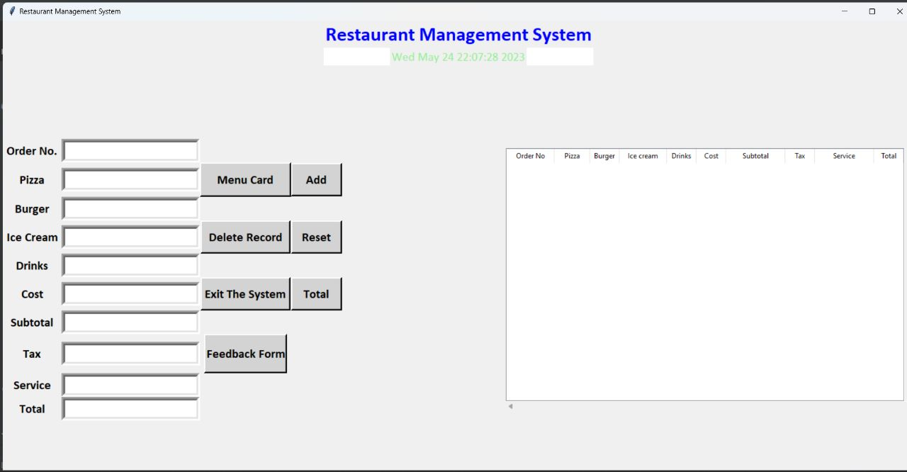

Manage Order list:  
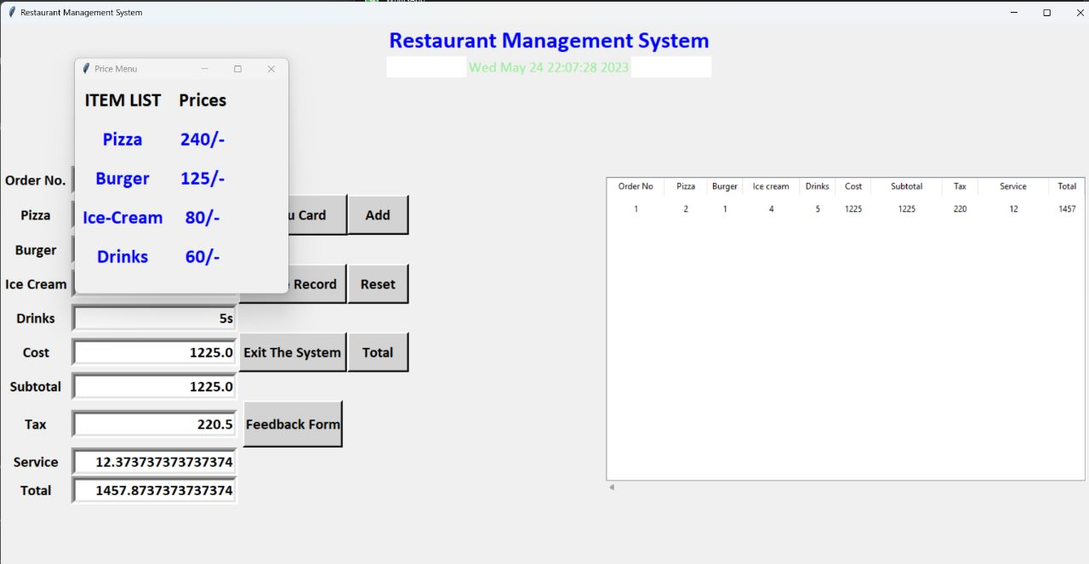

Create user:

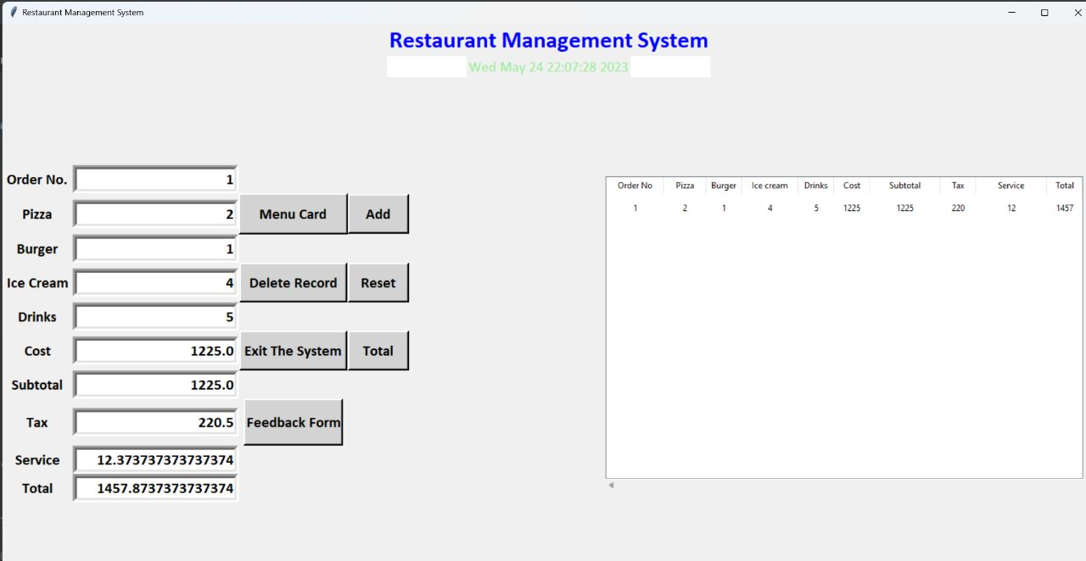

Avoiding Duplicate entries:  
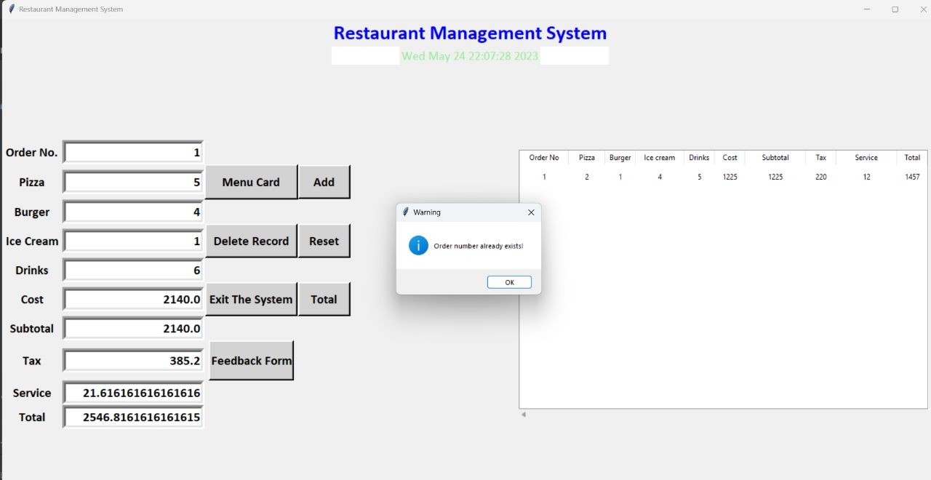

Edit/Delete user:

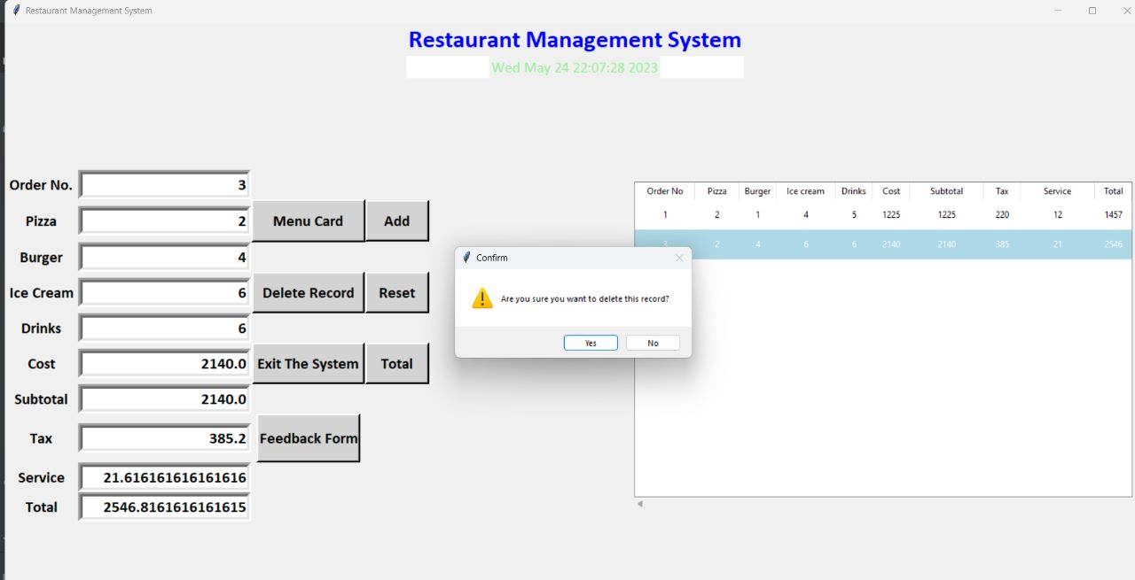

Customer Feedback:

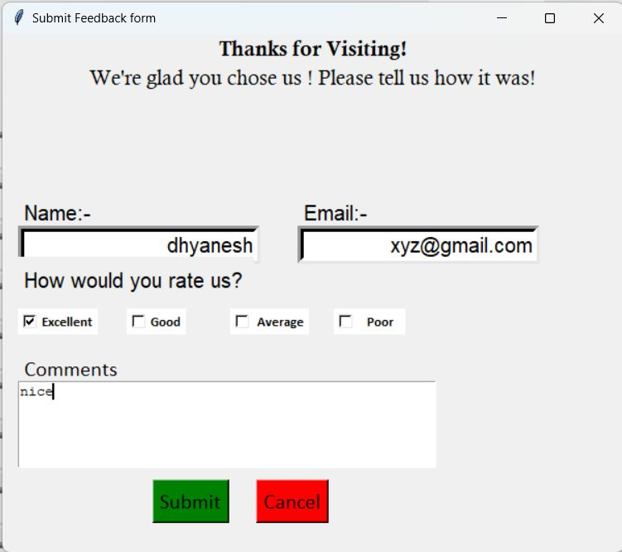

Data base Record:  
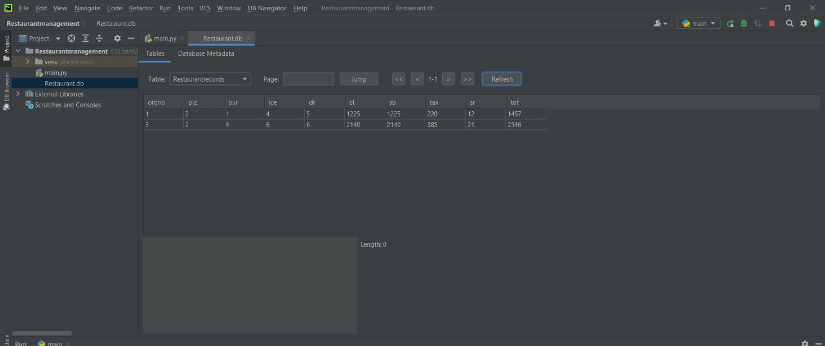

Code:

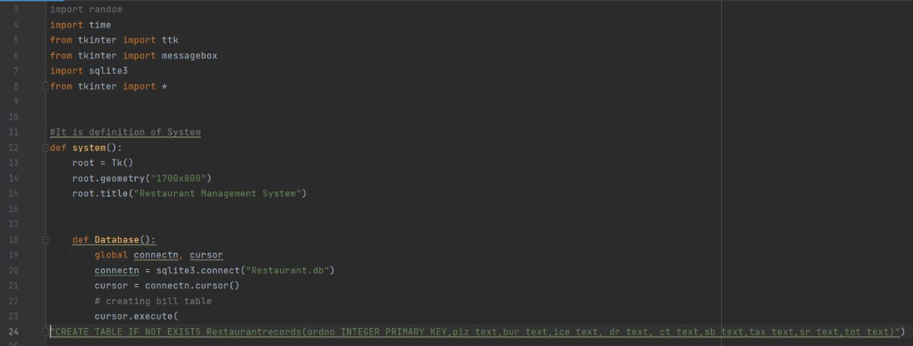

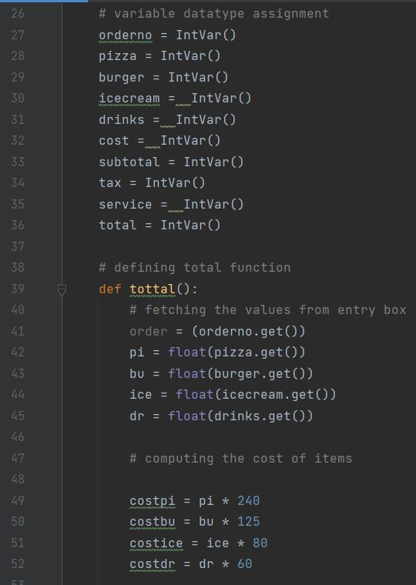

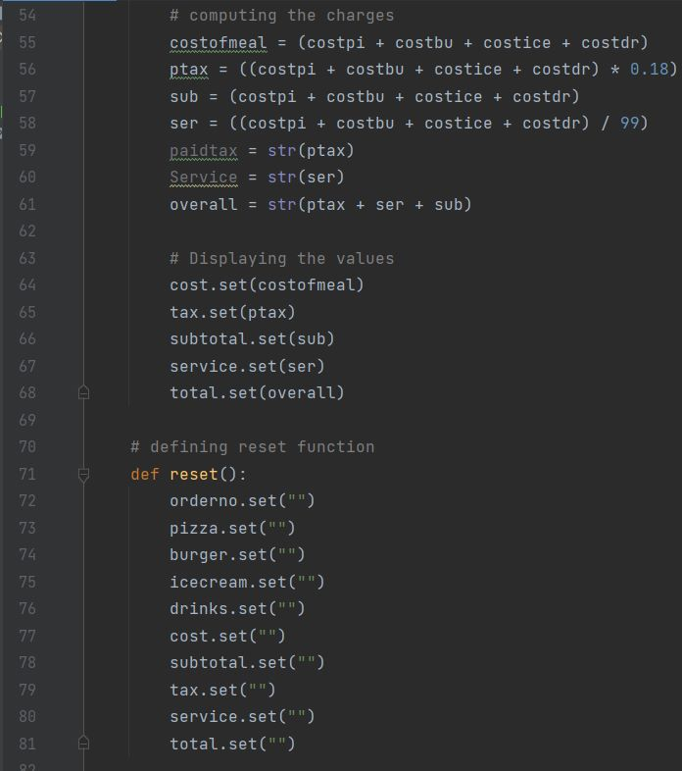

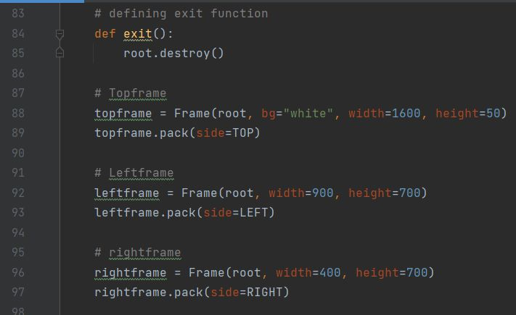

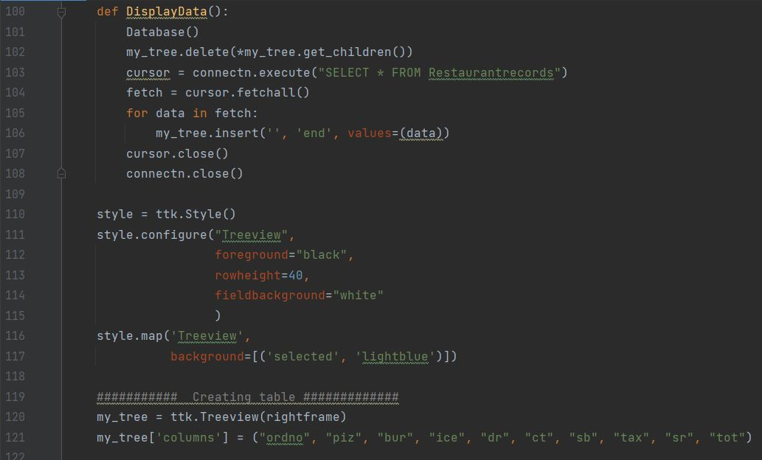

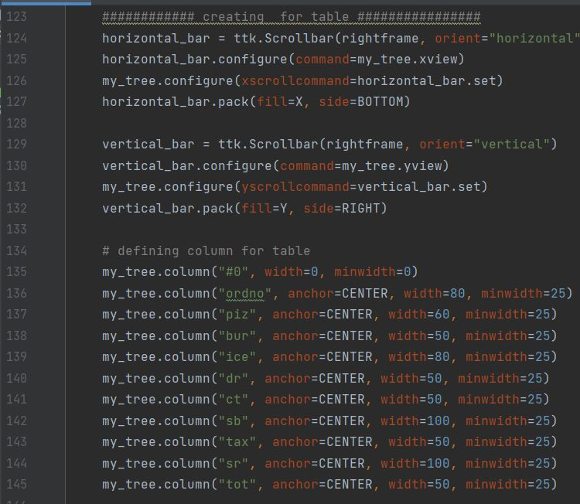

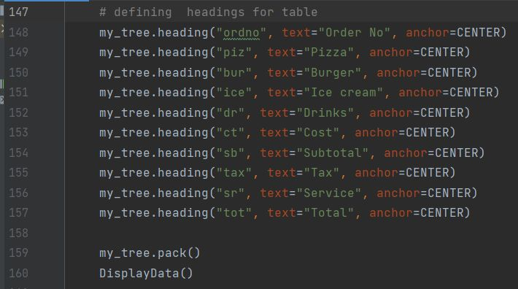

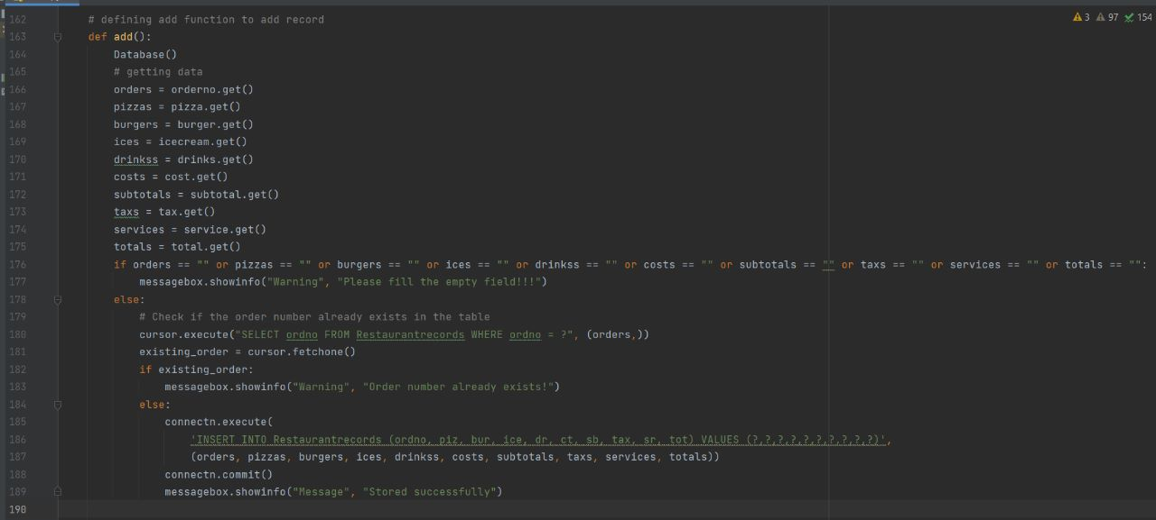

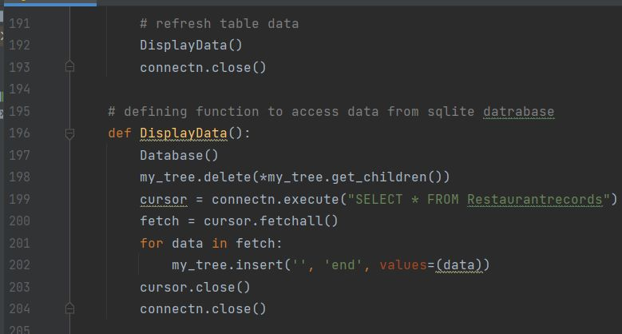

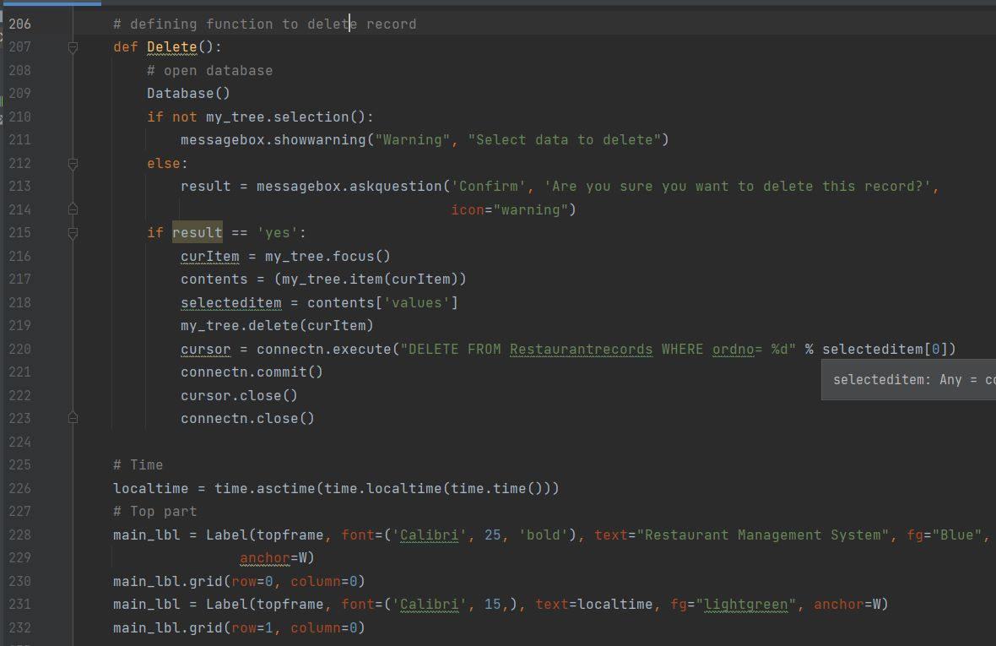

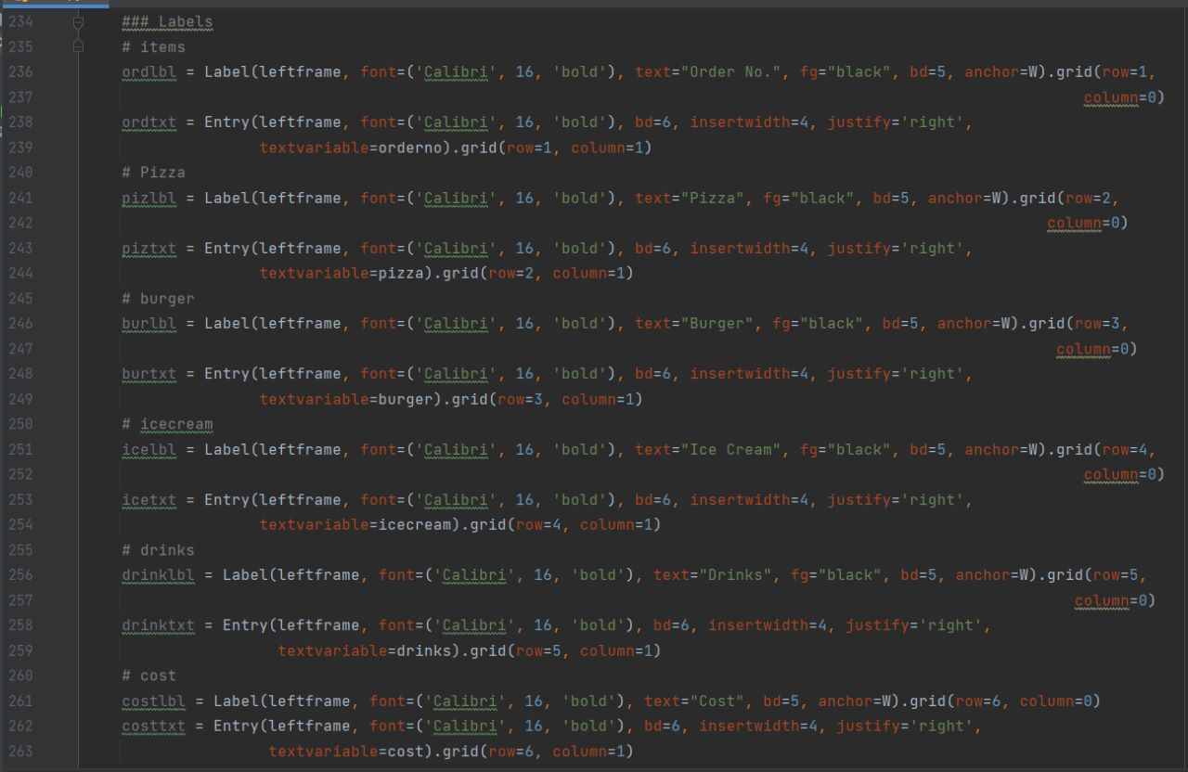

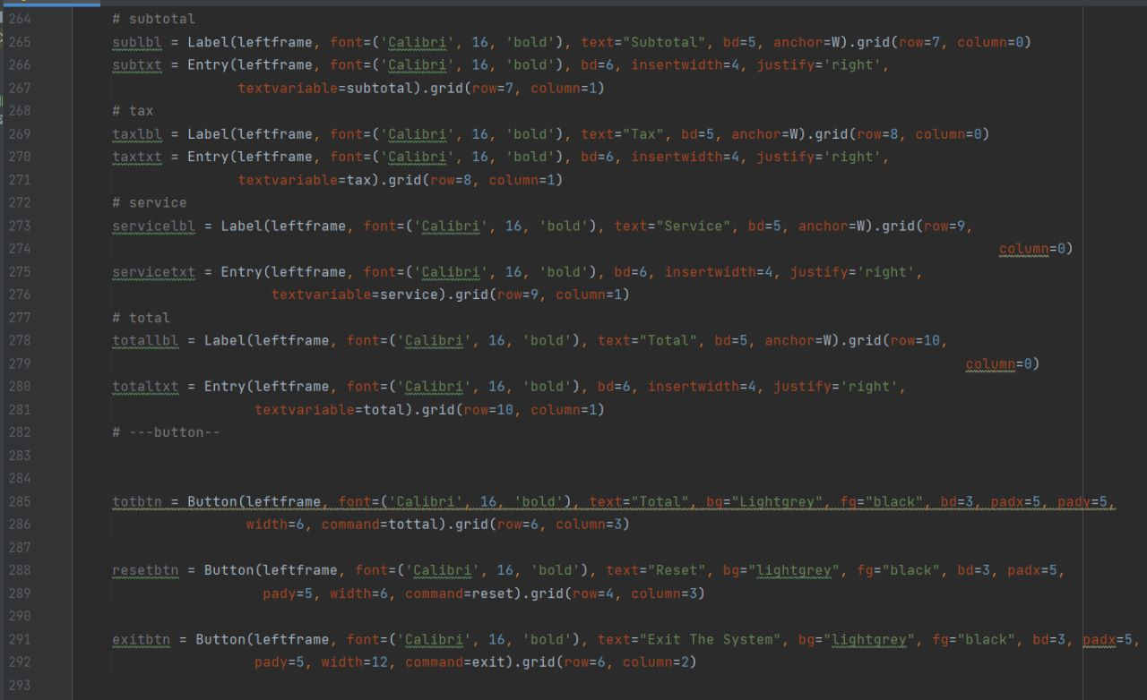

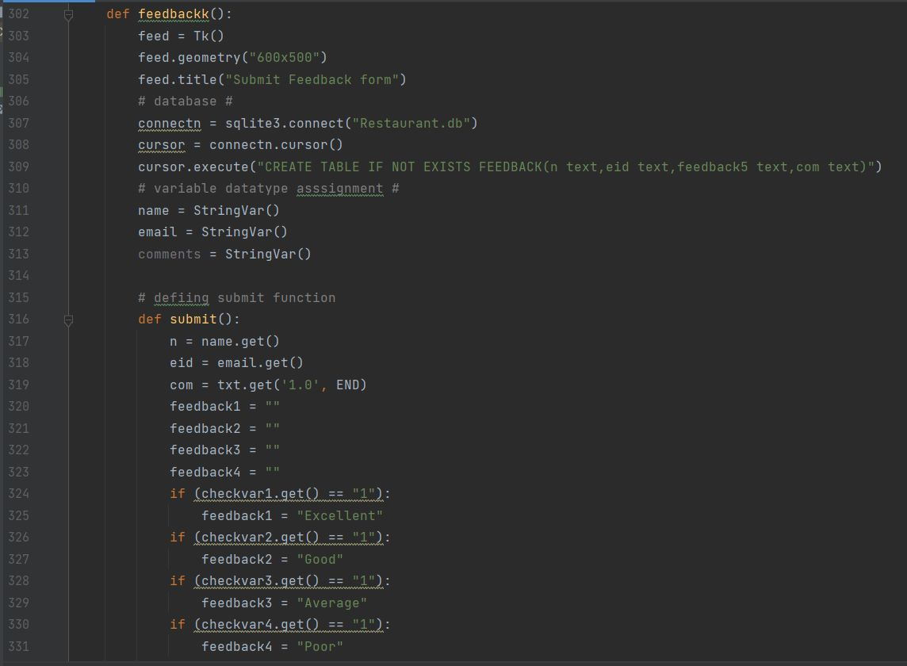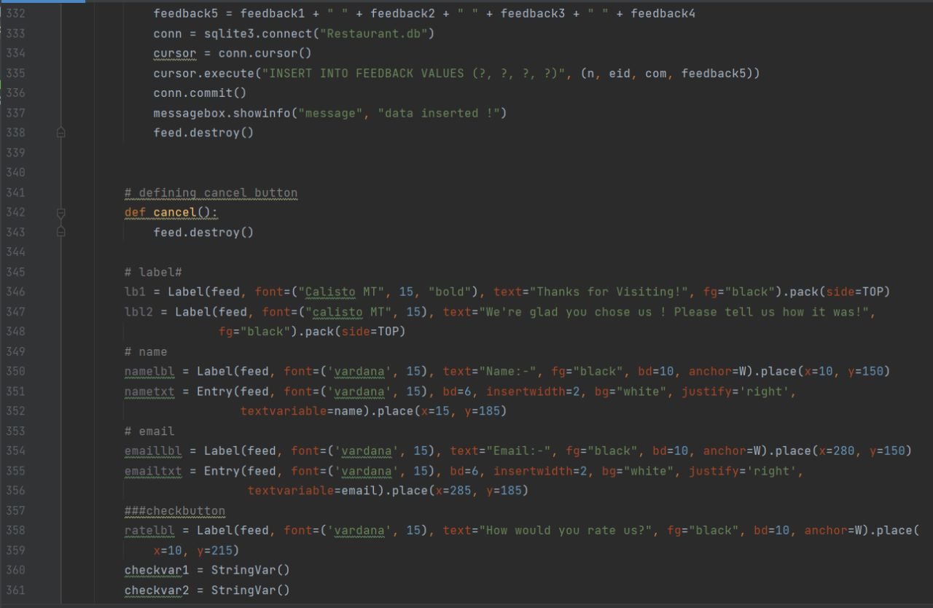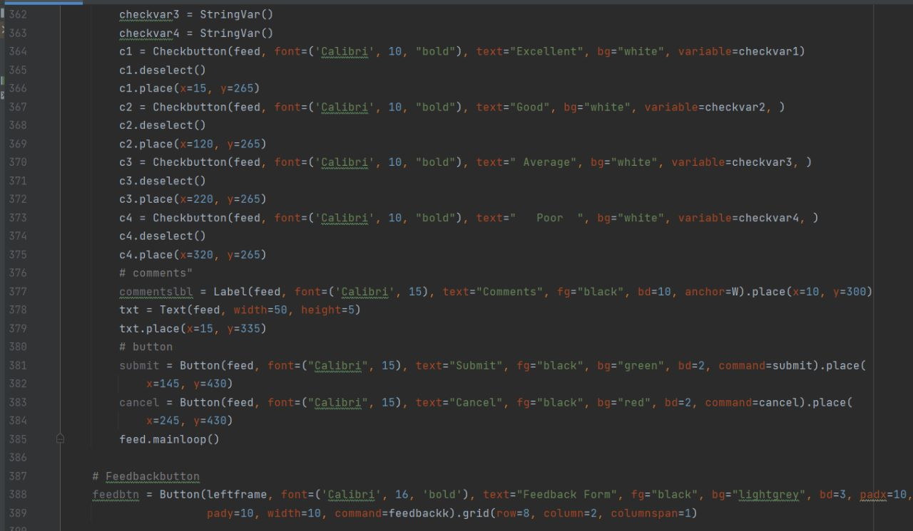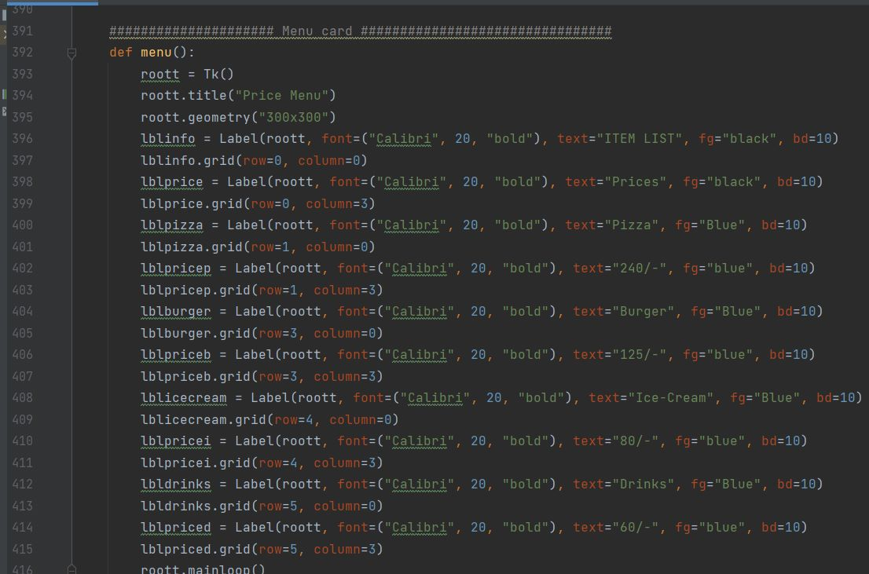

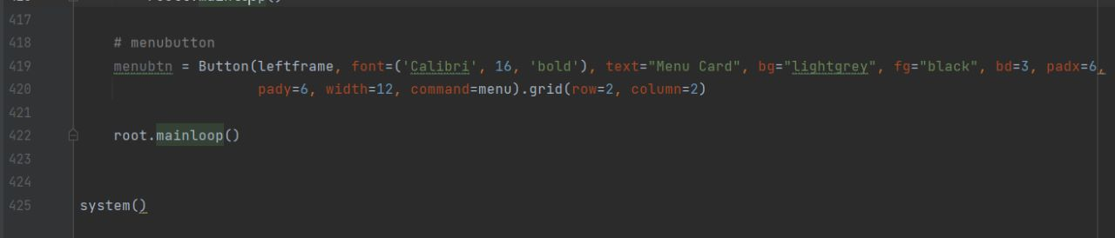

Conclusion:

This is achieved through an easy to use graphical interface menu options. The users can add any number of items to the order from any of the available food by adding the required number of each item.Once the items are added user can get the total and confirm their order and give their ratings and reviews to the restaurant.

Team Members:

1. Gaddam Dhyaneswar Reddy -AM.EN.U4ELC20013.
2. P.Nivas – AM.EN.U4ELC20027.
3. T.Krishna Prasad – AM.EN.U4ELC20034.
4. T.Prapul Prasad – AM.EN.U4ELC20035.